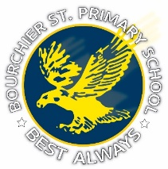
Bourchier Street Primary School
TRANSITION PROGRAM FOR
2025 FOUNDATION STUDENTS
Transition Program
Transition Sessions
Term 3
Session 1: Friday 23rd August
Session 2: Friday 6th September
Term 4
Session 3: Friday 11th October
Session 4: Friday 25th October
Session 5: Friday 8th November
Session 6: Friday 22nd November
All sessions are from 2.15pm – 3pm

Term 3
Children & Parents
Two play-based learning sessions.
Term 4
Children
Four sessions where children will
experience Art, Performing Arts,
PE & Library Activities.
Parents
Four sessions where parents will gain
information about:
Practical suggestions for starting school.
Student Wellbeing
Reading
Healthy Eating and more…..
Orientation Day is
Tuesday 10th December 2024
From 8.30am – 10.55am
Meet your teacher
Classroom Session

All Welcome
Bourchier Street Primary School – Cnr Bourchier St & Balaclava Road Shepparton – (03) 5821 3488

